|  |
| --- |
| A.E. MOVIE dATABASE  A.E. MOVIE dATABASE  RAD Development  The ImpostersRAD Development |
| **The Imposters**  **The Imposters**  130 Murdoch Dr  Murdoch WA, 6150  130 Murdoch Dr  Murdoch WA, 6150  Phone 1800 001 001  Email imposters@amongus.wa.au  Phone 1800 001 001  Email imposters@amongus.wa.au |



Table of Contents

Github snapshot 1

Project Management Plan 2

Introduction 1

Scope 1

In Scope 1

Out of Scope 1

Quality Objective 1

Roles and Responsibilities 1

Test Methodology 2

Overview 2

Test Levels 2

Bug Triage 2

Suspension Criteria & Resumption Requirements 2

Test Completeness 3

Test Deliverables 4

Resource & Environment Needs 5

Testing Tools 5

Test Environment 5

Hardware Environment 5

Required Software 5

Terms / Acronyms 5

CITE Business Rules 7

CITE Managed Services QA 7

A.E. Development Requirements 7

Responsive vs Adaptive 10

Our Decision 11

# Github snapshot

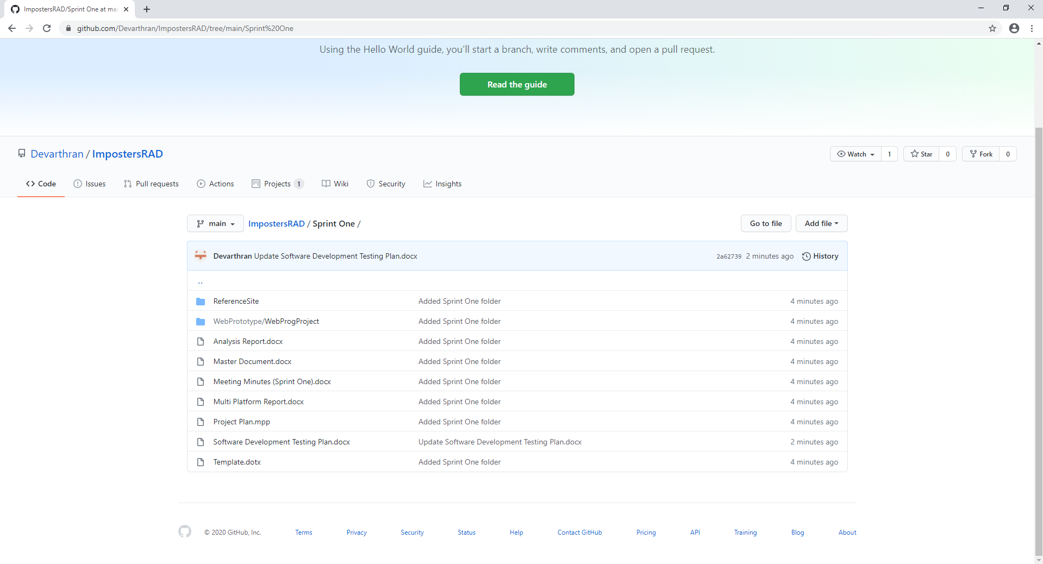

https://github.com/Devarthran/ImpostersRAD

# Project Management Plan

